IT Management for Business (ITMB)
Annual Review Report 2017/18
(incl. current student information for 2018/19)

This document provides the template for a University to complete their Annual Review Report for Tech Partnership Degrees. The report must be submitted to Tech Partnership Degrees by 30th November 2018 and forms part of Tech Partnership Degrees’ quality assurance process for Universities who have been accredited to offer the ITMB Honours Degree.
The report will review the previous academic year and provide up to date student numbers that include the current year.
Completed reports together with progression spreadsheet should be sent in electronic form to Tech Partnership Degrees at sue.stevens@tpdegrees.com.

CONFIDENTIAL

University details
University:
Course title:
Department/school/division name:
Name of programme leader:

Section 1 - 2017/18 Review
Please provide a review of the previous academic year in the following areas:

- ITMB programme – comments on the degree content
Learning Outcomes and Skills Requirements
Did you find it difficult to meet any of the learning outcomes and / or skills requirements; if so, which ones?

Would you like to see any additions to the learning outcomes?

- ITMB programme – significant changes
Please briefly outline any major changes made to modules or other content of your ITMB degree, and any impact on compatibility with the Learning Outcomes and Skills Requirements.

- ITMB programme – assessment of the Industry Insight Lectures
Please state in full how and when the Industry Insight Lecture series was assessed at your university.

- Graduating ITMB students
For those ITMB students that graduated in 2018, please provide the following information on the classes of degree and first career destinations.
4.1 ITMB graduating student results
Students graduating from ITMB are important ambassadors for the degree and it is useful to identify both their overall achievement and their first destinations after graduation.

Qualification Gained | Number of Students |  | Course Percentage
 | M | F | M | F
Firsts
Upper Seconds
Lower Seconds
Thirds
Non-Honours
Fails
Masters – Distinctions
Masters – Passes
Masters – Fails
Totals

Please comment on any patterns you see in this year’s results compared to those of previous years.

4.2 List of first destinations for graduating ITMB students
Please provide information on the employers, careers and locations of graduating ITMB students.
The sample table below may be used, or alternatively you may provide the information in other formats if this is easier. We understand that in some cases job title and salary cannot be provided.

Employer and Location | Job Title | Salary

- National Student Survey (NSS) Results
Students’ opinions on the quality of their courses via the NSS help to inform the choices of prospective students and assist institutions and the Tech Partnership in enhancing the student experience. Please provide your results indicating whether it is at course level or otherwise?

- Successes / Achievements / Case Studies
Please tell us about any ITMB student success stories. These may include winners of competitions, awards or anything you think deserves highlighting. We would like to showcase as many of these as possible on our website. If easier, please provide links to any websites highlighting these success stories.

Section 2 – 2018/19 Current Student Information

- ITMB programme – student numbers
Please state the number of students on your programme as of 1st November 2018. This date accommodates an appropriate period for any course ‘changers’ and early leavers.

7.1 Student numbers
Year | Male | Female | Total
First
Second
Placement
Final
Masters (if applicable)
Total in all years

7.2 Other comments
Please use this section for any comments on the figures provided, e.g. whether any students are taking exams only.

- ITMB programme – student progression

8.1 Progression table
Please use the separate excel spreadsheet provided with this report to produce a single table to cover all of your students, in the following format, showing the progressions of students during the past three, four years or five years, whichever is appropriate for your degree. (Please note that the spreadsheet in Figure 1 is a worked example only from a fictitious ITMB course)

8.2 Reasons for student wastage/attrition
Please use the supplied spreadsheet to list causes for students not progressing to the next level or dropping out of the ITMB degree. Below is an example of a completed spreadsheet.

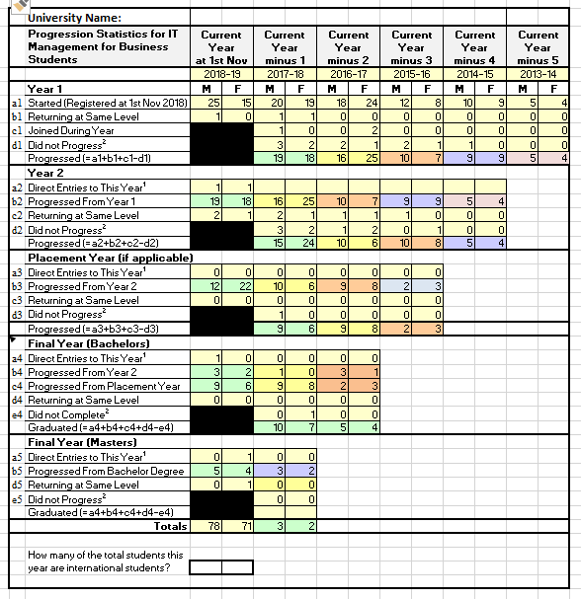
Figure 1

Notes

1. Note that this grid allows for a Master’s year as part of the programme. If your university does not have a Master’s option for ITMB then please ignore the bottom cells.
2. Students may have joined directly in this year for the following reasons:
They have joined the course directly from outside the university (usually, but not always, at year 1).
They have transferred into the course from other courses within the university.
They have returned after a period of intermission.
3. Students may have failed to progress in this year for the following reasons:
They have failed the year and are required to leave the university.
They have failed the year but are allowed to repeat it at the next opportunity.
They have opted to withdraw from the university, for various reasons.
They have chosen to transfer to another course within the university.
They have chosen to temporarily intermit their studies but plan to return after one or more years.
4. Three Year Degrees do not require 'Current Year minus 4' or 'Placement Year'
5. Part-time students will need special treatment. Such students should be treated as 'Staying at Same level/Intermitting' if they have not completed a year.
6. The figures for the ‘Current Year’ relate to those students who were registered at 1st November. If any ‘progressing’ students in years other than year 1 started the year but were not registered at 1st November, they should be shown as ‘Did not Progress’ in the previous year.

- Student placements and internships
Please provide information about the placements of your students in:
- The current academic year
- The summer that has just passed
The sample table below may be used, or alternatively you may provide the information in other formats if this is easier.

Employer and Location | Role and other comments | Type of Placement

- The ITMB annual review reporting process
Have you any comments about this annual review form or the review process? Is there any other matter of general concern that you would like to bring to the Tech Partnership’s attention?

Thank you for providing this information

Tech Partnership Degrees will compile a summary report of all the Annual Review Reports and present this to the Employer Network. Any matters that require feedback will be drawn to the attention of the University programme leader as appropriate by Tech Partnership Degrees.

Tech Partnership Degrees
info@tpdegrees.com / www.tpdegrees.com

Tech Partnership Degrees Ltd - A company limited by guarantee, registered in England and Wales (07223753) - Registered office: Victoria House, 39 Winchester Street, Basingstoke, Hampshire RG21 7EQ - VAT no GB 294295170

